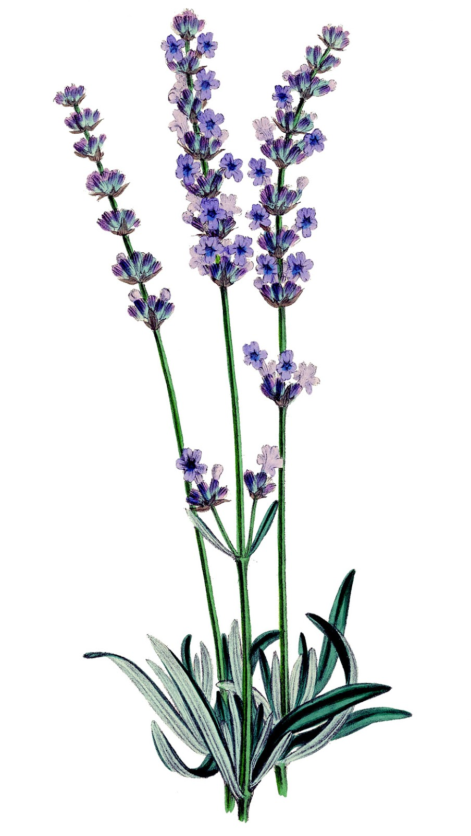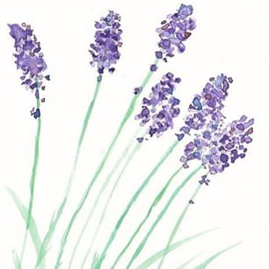

**You are Invited**

**to an**

**Introduction to Essential Oils!**

Discover how therapeutic grade essential oils can improve your health and well-being!

**Date & Time:**

**Where:**

**Cost:** Free

**R.S.V.P Required by:**

**Please call:**

**Or Email:**

Although the healing powers of essential oils have been known for centuries, their introduction into popular culture and modern medicine has had a profound effect on how we view health, vitality, and wellness.

**Join us for an educational and fun-filled evening and experience the joy of therapeutic grade essential oils!**

**And bring your friends**!

**We will share essential oils that will:**

* Ease pain, depression, and stress!
* Increase your energy level and stamina!
* Restore a calm and balanced mood and enhance mental focus!
* Stop colds and flu’s before they make you sick!